C PROGRAMMING TO FIND FACTORIAL OF A GIVEN NUMBER WITHOUT USING RECURSION

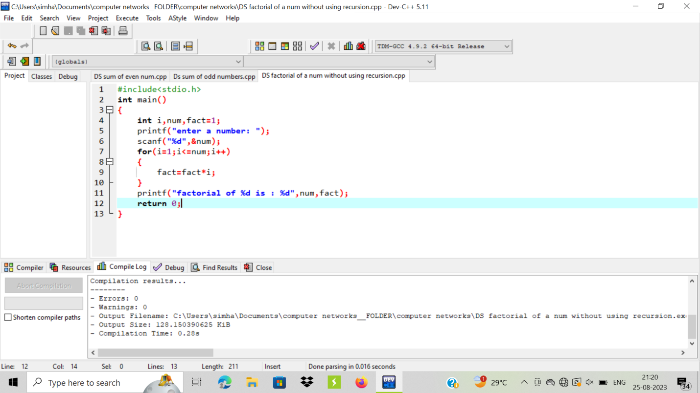

OUTPUT:

